**MG 220: Data Analysis Project**

To: Dr. Craig

From: [Jordan Lewis](mailto:jl1957@desales.edu)

Date: 5/2/2022

Subject: Analysis of Abortion Rates, Median Household Income, and Unemployment rate figures in the United States

**Section 1: Overview**

In this study, I have researched and analyzed the data on abortion rates and incomes in the United States within federal and local levels from the years of 2019, 2018, 2016, 2015, and 2014. The main issue that I am focusing on is the average rate that women are getting abortions per year. I would like to analyze how this number fluctuates depending on different incomes in different states and the unemployment rates in those same states within that same time frame in the United States. I will be using Minitab to analyze the data.

This topic is interesting to me because I am aware how debated and dicusseed the topic of abortion is. I think abortion is a procedure that can strongly affect a women in either a positive or negative light. It is also a procedure I believe is deeply misunderstood and needs to be talked about and more people should be aware and educated on the effects and situations that that lead to someone getting an abortion, and what happens during and after the procedure. Through my research, I hope that not only I, but others understand the deeper elements and parts of abortions.

**Section 2: Statement of the Hypothesis**

During my research and data collection from Kaiser Family Foundation, Iowa State University, and the National Center for Education Statistics, it will be intriguing to see how each state’s abortion rates, unemployment rates and median household incomes change and how they could possibily relate to each other. Abortion data was collected from each state over 5 years by the Kaiser Family Foundation. Each state reported their data at the end of the year and the rate was calculated out of 1000 women aged 15-44. Because this is self reported data from each state and only includes legal abortions, so the actual abortion rate could be higher than what is in the data because of illegal abortions. Median household income figures were collected through each of the 50 states by the National Center for Education Statistics. Unemployment rates were collected by Iowa State University through each of the 50 states.The hypothesis listed below will be tested and analyzed to see relationships and trends.

Null Hypothesis: There is no difference in abortion rates from each region in 2019 collected by the Kaiser Family Foundation

Alternative Hypothesis: There is a difference in abortion rates from each region in 2019 collected by Kaiser Family Foundation

Null Hypothesis: There is no difference in median household income from each region in 2019 collected by the National Center for Education Statistics

Alternative Hypothesis: There is a difference in median household income from 2019 in each region collected by the National Center for Education Statistics

Null Hypothesis: There is no difference in unemployment rates from 2019 in each region collected by Iowa State University

Alternative Hypothesis: There is a difference in unemployment rates from 2019 in each region collected by Iowa State University.

Null Hypothesis: There is no association between abortion rates from median household income, and unemployment rate

Alternative Hypothesis: There is an association between abortion rates and median household income, and unemployment rate

**Section 3: Data and Analysis Methodology**

The data collected is from Kaiser Family Foundation, National Center of Education Statistics, and Iowa State University like I stated before. From the KFF, I collected data on abortion rates from the years 2019, 2018, 2016, 2015, and 2014. I also collected data from the NCES on median household income for those years as well in each of the 50 states. I also looked at unemployment rates with those same parameters provided by Iowa State University. These figures also include the District of Columbia.

To test the hypotheses stated below, I will be using a Tukey Comparison ANOVA test to compare the change of each variable throughout each region of 2019 . I will be using a multiple regression analysis to see the correlation and probability that abortion rates might be correlated with unemployment rates and median household income in 2019. To perform these tests, I will be using Minitab with the dataset I formatted with Excel.

**Section 4: Results**

**One- Way ANOVA: Abortion Rates (2019) vs Region**

My first hypothesis was that there is no difference between abortion rates through the each region. From the results of the tukey ANOVA test, we are 95% confidence that there is no difference in abortion rates through the past 5 years. There is no sigficiant data suggesting there is not a difference in abortion rates throughout the years. We fail to reject the null hypothesis that there is a difference

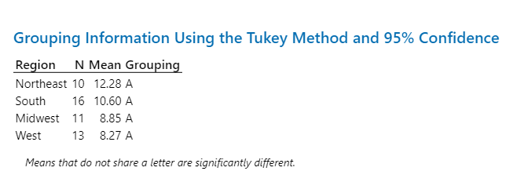

The p-value of the test was .250. This is greater than .05 which means there is a 25% chance that my null hypothesis is true which is above the 5% significance level. The graphs also provide evidence to these findings.

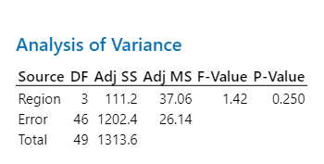

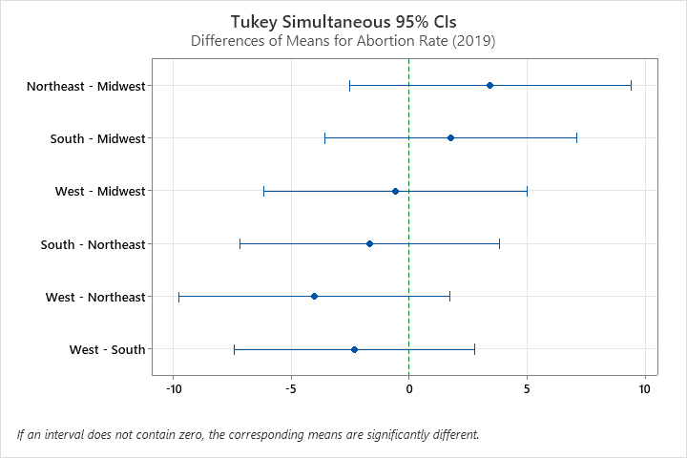

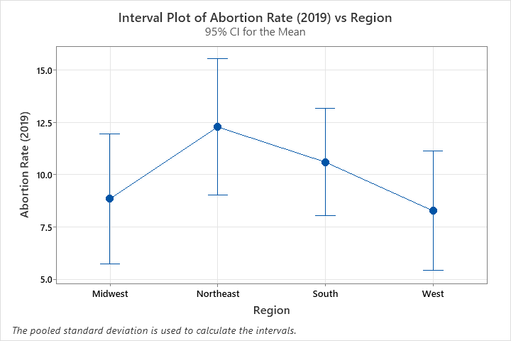

**One- Way ANOVA: Median Household Income (2019) vs Region**

My second hypothesis was that there is no difference between median household income through each region. From the results of the Tukey ANOVA test, we are 95% confident that there is a difference in median household incomes through each region. There is sufficient data suggesting there is a difference in median household incomes throughout the years. We reject the null hypothesis that there is not a significant difference in median household income.

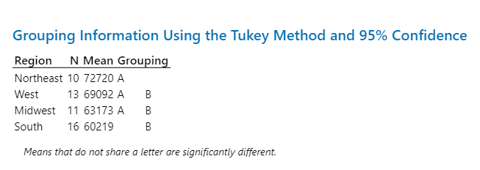

The p-value of the test was .019. This is less than .05 which means there is a 1.9% chance that my null hypothesis is true which is below the 5% significance level. The graphs also provide evidence to these findings.

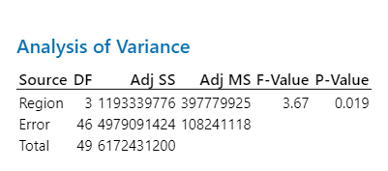

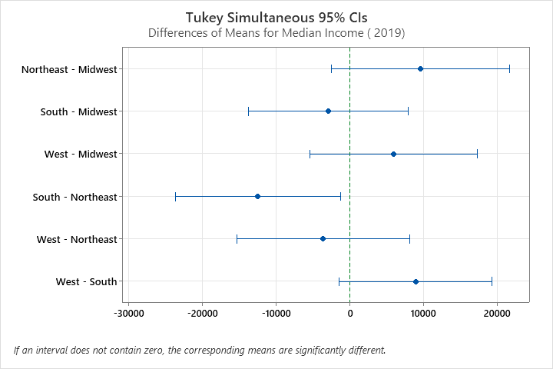

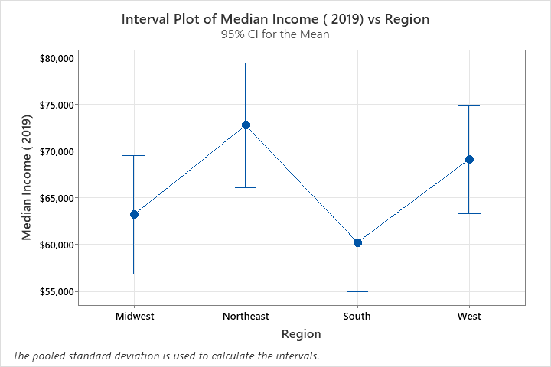

**One- Way ANOVA: Unemployment Rate (2019) vs Region**

My third hypothesis was that there is no difference between unemployment rates through each region. From the results of the Tukey ANOVA test, we are 95% confident that there is no difference in unemployment rates through each region. There is sufficient data suggesting there is no difference in unemployment rates throughout each region. We fail to reject the null hypothesis that there is not a significant difference in unemployment rates.

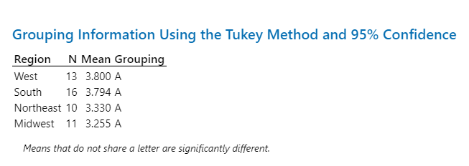

The p-value of the test was .197. This is more than .05 which means there is a 19.7% chance that my null hypothesis is true which is higher than the 5% significance level. The graphs also provide evidence to these findings.

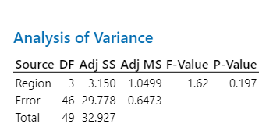

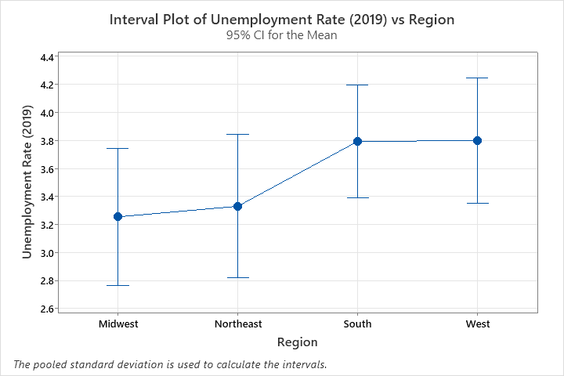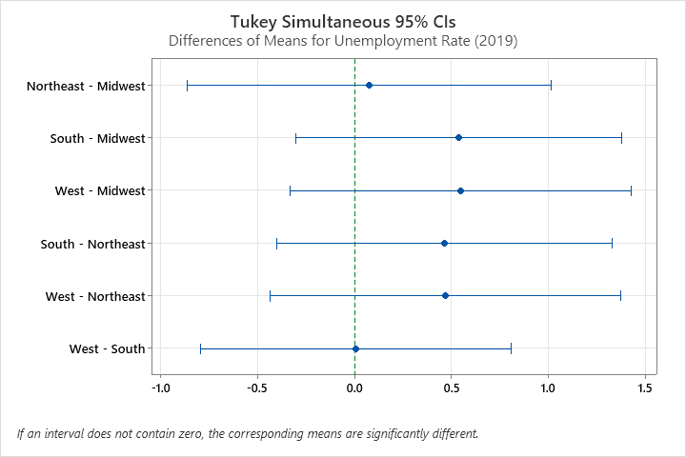

**Multiple Regression Analysis: Abortion Rates 2019, vs MHI 2019 URate 2019**

While testing for association between abortion rates in 2019 and median household income and unemployment rates in the same year, it was found that there is data to suggest that there is an association between abortion rates and median household income and unemployment rates. Median household income has a p-value of 0 and unemployment rate has a p-value of .012. Median household income and unemployment rates’ p-value is less than 5%. We reject the null hypothesis for both median household income and unemployment rate.

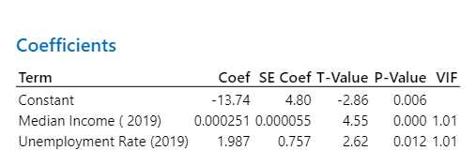

33.90% of variability in abortion rates of 2019 were explained by median household income and unemployment rates. This makes sense to me because a lot of womens’ reason on getting an abortion is financial issues and stability with jobs and income but does not explain all the factors influencing abortions and abortion rates which explains the estimated 70% of variability not explained by median household income and unemployment rate.

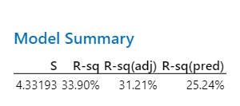

The regression equation is below:

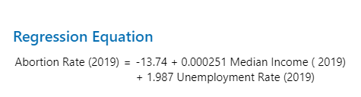

From the regression equation, it shows that there is a positive correlation between both median household income and unemployment rate. This means as abortion rates increase both median house income and unemployment rates increase.

When looking at each individual scatter plot, they reveal that abortion rates and median household incomes have a moderate positive correlation and abortion rates and unemployment rates have a weak positive correlation.

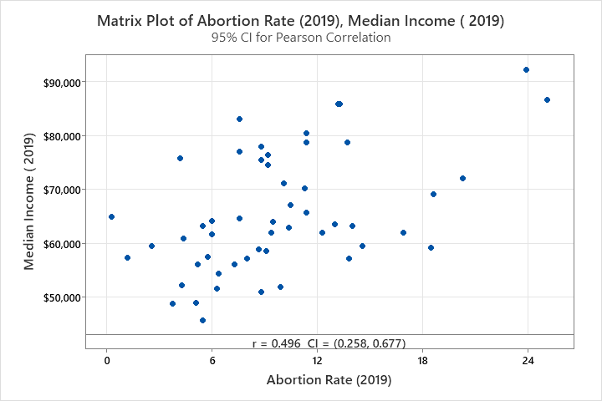

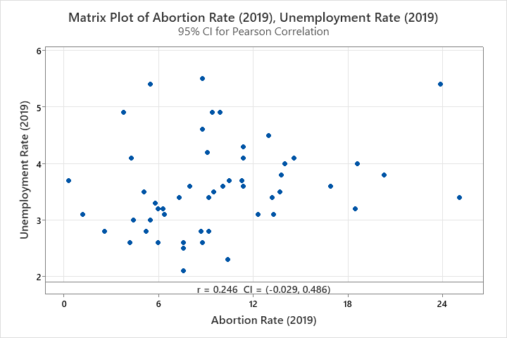

**Section 5: Discussion and Conclusion**

Abortion has been a raging topic from the past decade and there have been many ideas and propositions to stop or slow the rate of abortions. Finding what influences women and what their backgrounds are can help better understand these kinds of issues. To dig depper into this topic, I gathered data on abortion rates, median household income, and unemployment rates from all U.S states including Washington D.C. To find the correlation and the movement over time, I conducted a multiple regression analysis and 3 different ANOVA comparisons for each variable to test my 4 hypotheses. After conducting my test, there was significant evidence to prove that abortion rates and unemployment rates are similiar in each region but not in median household incomes. There was a slight association between abortion rates and median household income and unemployment rates. I was surprised but also not surprised to find these results as I knew financial reasons and job stability was a huge factor for women in getting abortions. What I found surprising was the moderately positive between median household income and abortion rates meaning as abortion rates go up, income goes up. You would think lower income states would have higher abortion rates because they have less money to support a child. I also knew there was a correlation with abortion and unemployment as without a job, you can not support a child and their needs. What I didn’t expect is how weak the positive correlation was. Of course, these two variables are not the only explanation of abortion as only 33%-34% of abortion rates were caused by median household incomes and unemployment rates. There many other factors that cause the fluctuation of abortion rates. Other variable might be, cost of living, funding of sex education and women focused healthcare operations, and legality of abortions in each state. Through this study and many other investigations, I hope we can learn more about abortions and truly come together to talk about it and clear up misconceptions about the topic.

**Work Cited**

“Annual Unemployment Rates by State.” *Annual Unemployment Rates by State | Iowa Community Indicators Program*, Iowa State University, https://www.icip.iastate.edu/tables/employment/unemployment-states.

“Digest of Education Statistics, 2020.” *National Center for Education Statistics (NCES) Home Page, a Part of the U.S. Department of Education*, National Center for Education Statistics, https://nces.ed.gov/programs/digest/d20/tables/dt20_102.30.asp.

“Rate of Legal Abortions per 1,000 Women Aged 15-44 Years by State of Occurrence.” *KFF*, 1 Dec. 2021, https://www.kff.org/womens-health-policy/state-indicator/abortion-rate/?currentTimeframe=4&sortModel=%7B%22colId%22%3A%22Location%22%2C%22sort%22%3A%22asc%22%7D.